Oracle RAC 19c on Oracle Linux 7.9 Database Creation with DBCA

Contents
Assumptions/Prerequisites 1
1 Database Creation with DBCA 2
2 Post Database Creation Verification 12
2.1 Check Database config status and Instances 12
2.2 Check the instance/SQLPlus 13
2.3 Check the RAC status 13
2.4 Check Instance and Listener on the second RAC node 14

Assumptions/Prerequisites

Verify ASM Diskgroups existence before executing dbca, here as oracle user with the grid infrastructure environment variables properly set.

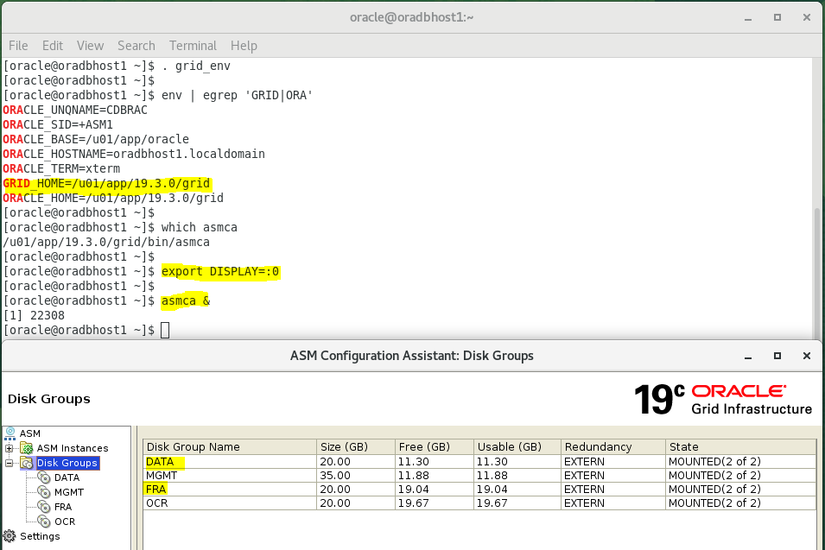

Database Creation with DBCA

Set the environment variables properly for ORACLE_HOME and not GRID_HOME
Set DISPLAY and execute runInstaller

[oracle@orahost1 db_1]$ date
Fri 15 Oct 22:07:56 CEST 2021

[oracle@orahost1 db_1]$ ps -ef | grep [p]mon
oracle 4248 1 0 20:31 ? 00:00:00 asm_pmon_+ASM1

[oracle@orahost1 db_1]$ env | grep ORA
ORACLE_UNQNAME=CDBRAC
ORACLE_SID=cdbrac1
ORACLE_BASE=/u01/app/oracle
ORACLE_HOSTNAME=orahost1.localdomain
ORACLE_TERM=xterm
ORACLE_HOME=/u01/app/oracle/product/19.3.0/db_1
[oracle@orahost1 db_1]$
[oracle@orahost1 db_1]$ which dbca
/u01/app/oracle/product/19.3.0/db_1/bin/dbca
[oracle@orahost1 db_1]$
[oracle@orahost1 db_1]$ dbca

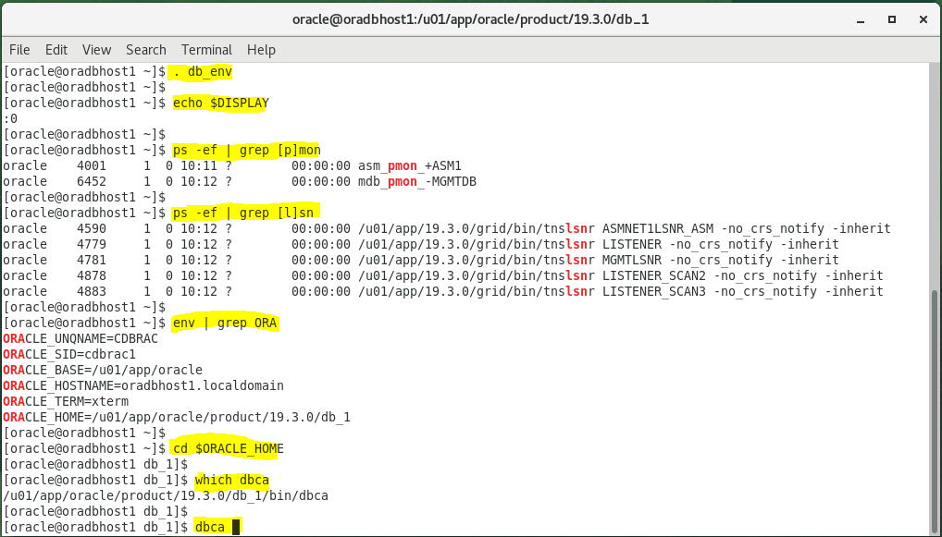

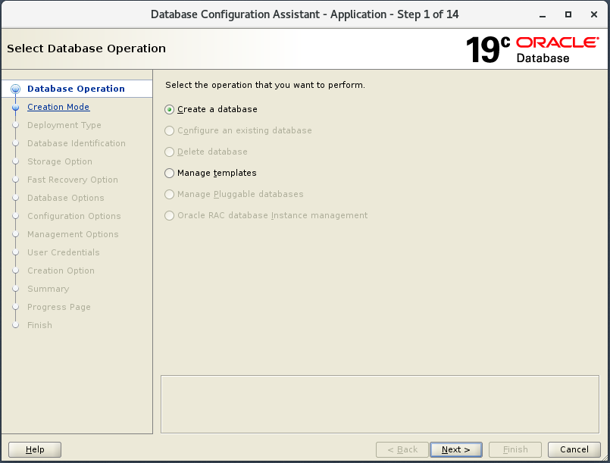

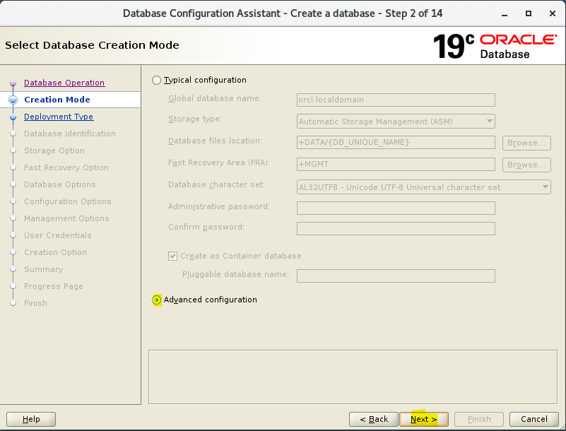

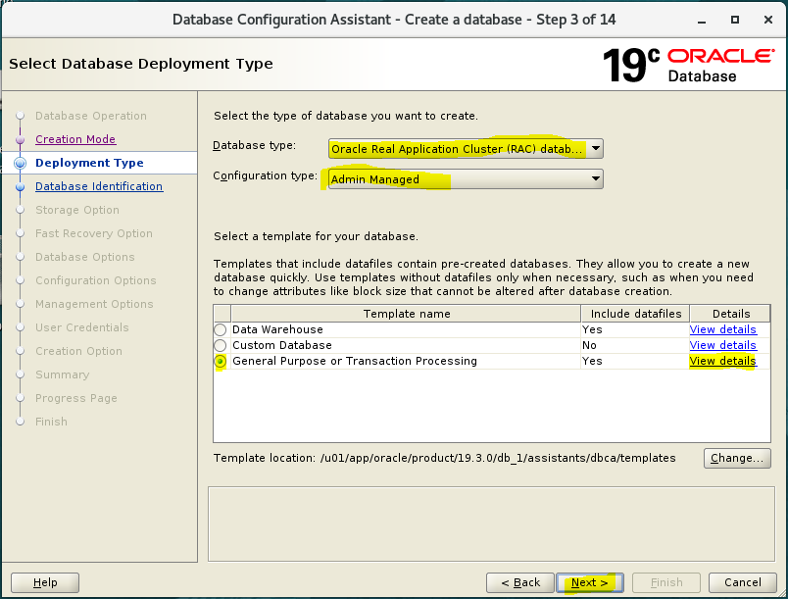

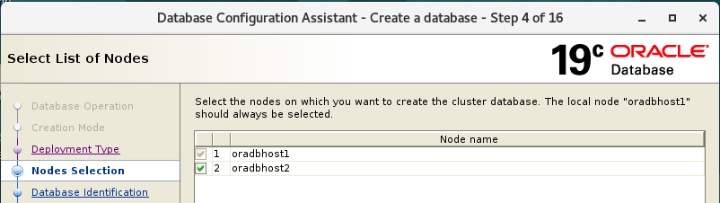

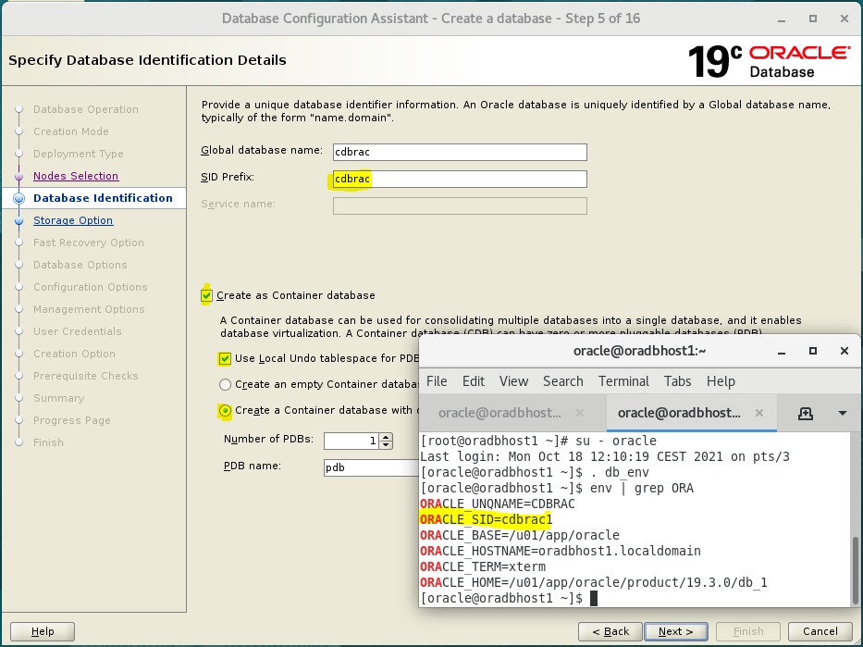

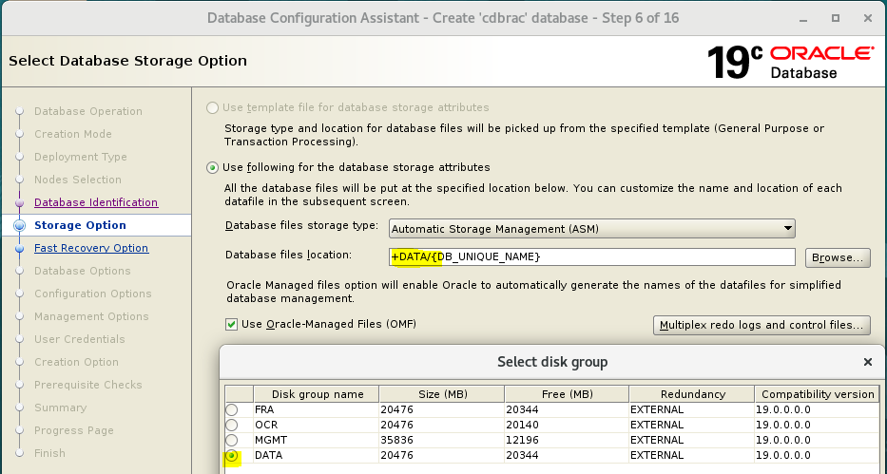

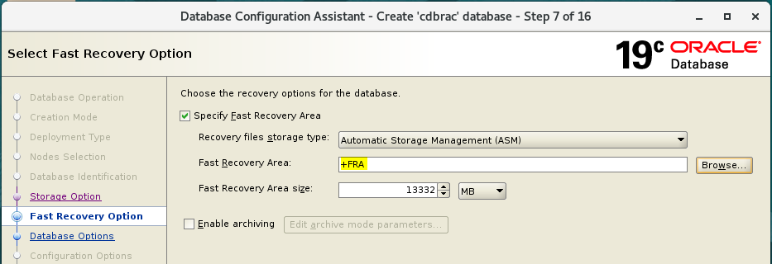

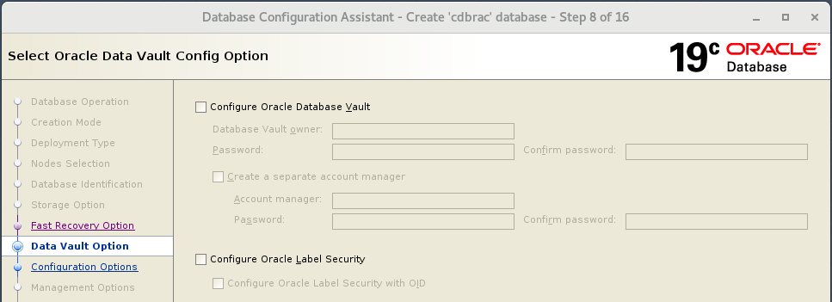

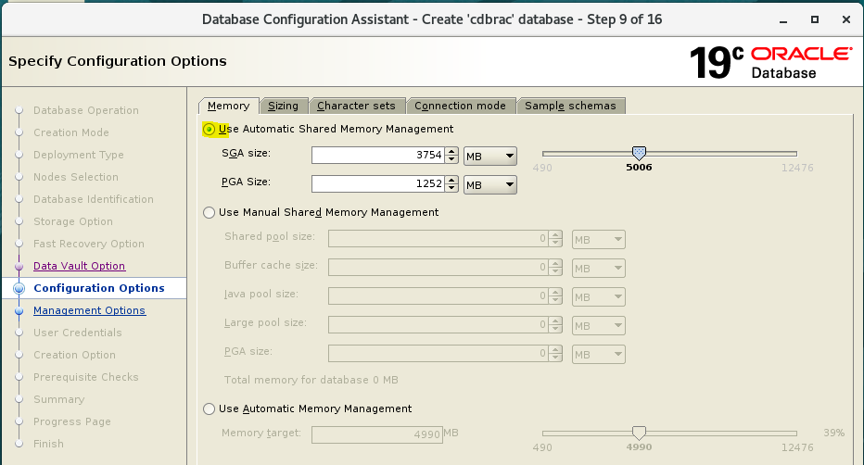

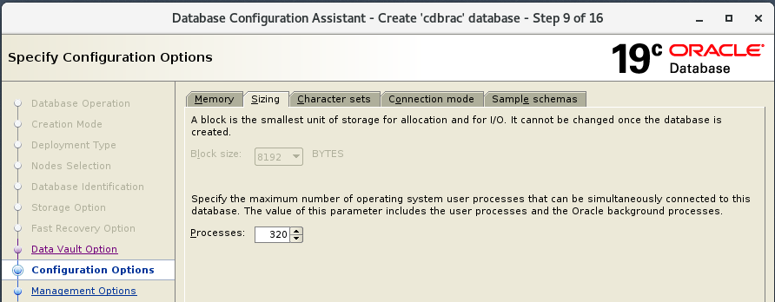

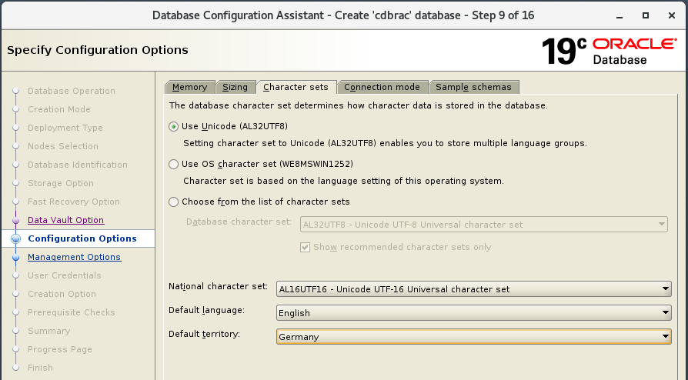

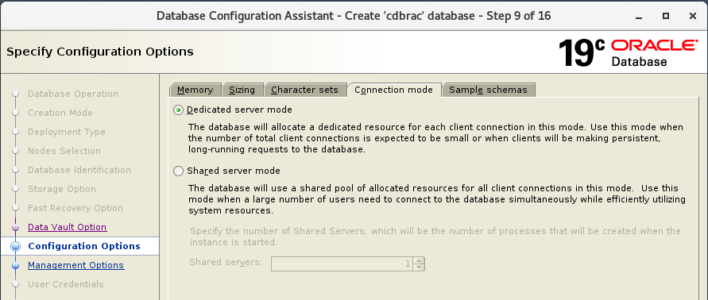
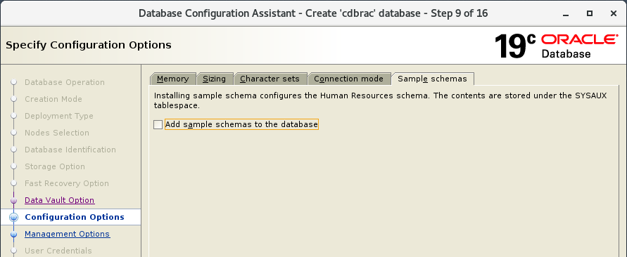

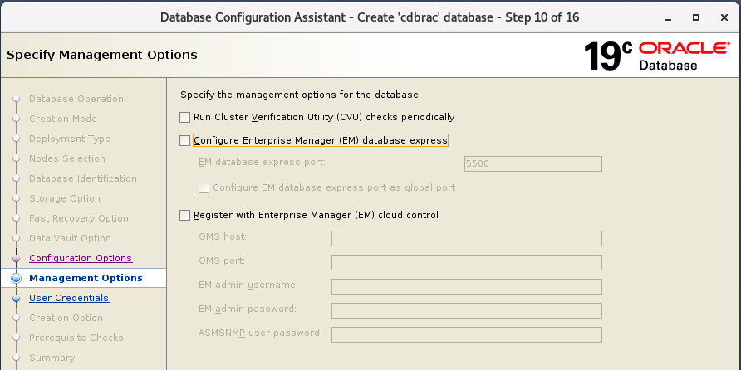

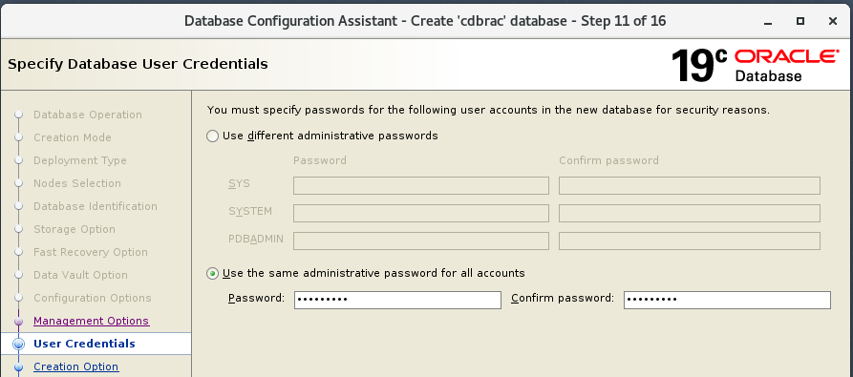
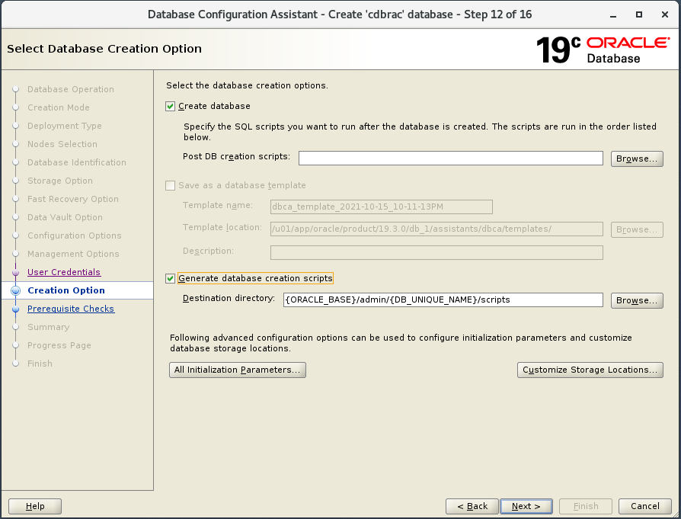

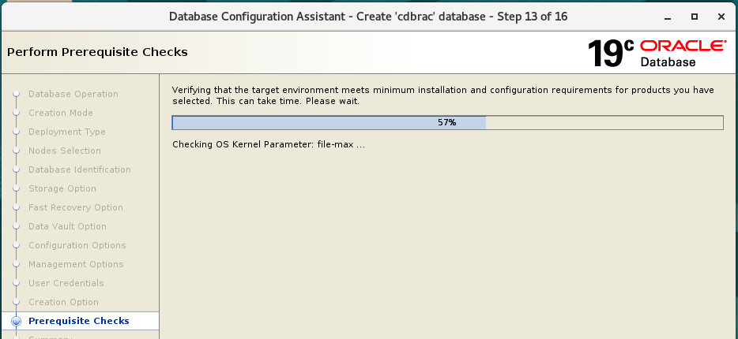

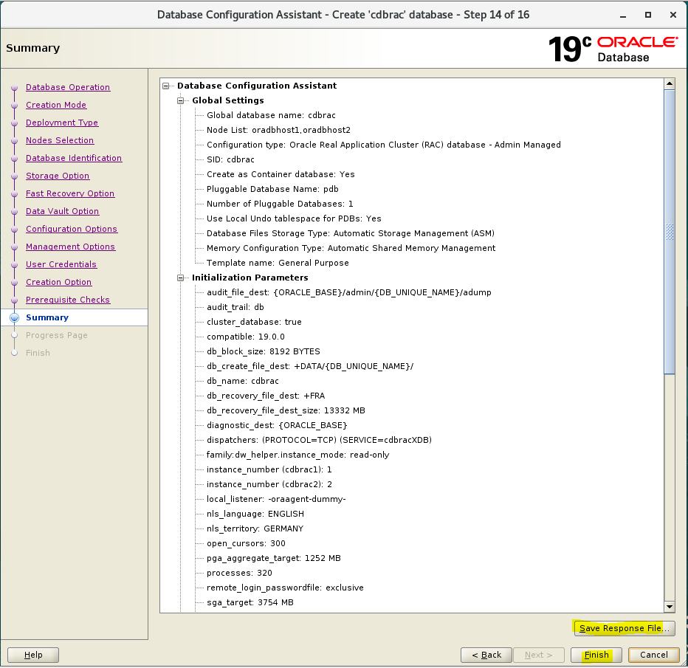

You can monitor the progress or have a look on the DBCA log or alert log

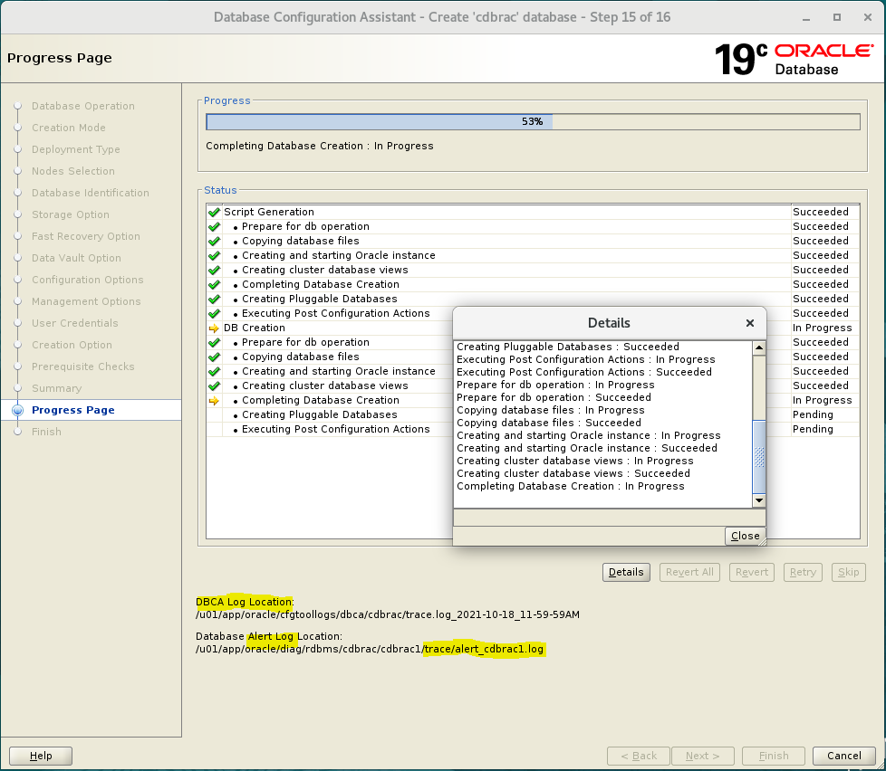

Check the Password Management to modify an account. For example I have unlock DBSNMP account. Then click Close to close the Database Creation.

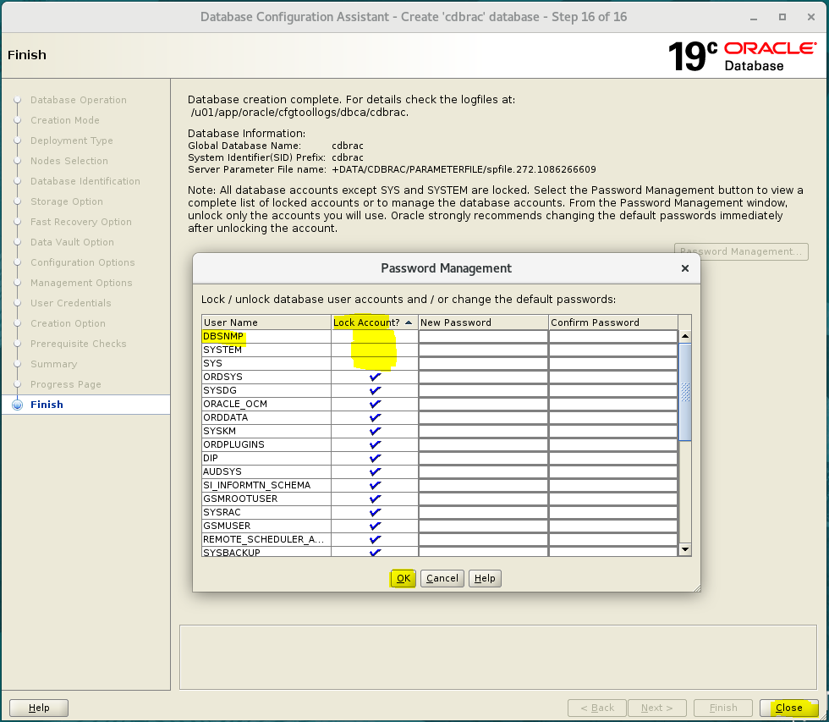

Post Database Creation Verification

Check Database config status and Instances

[oracle@oradbhost1 ~]$ ps -ef | grep [p]mon
oracle 4001 1 0 Oct18 ? 00:00:02 asm_pmon_+ASM1
oracle 6452 1 0 Oct18 ? 00:00:02 mdb_pmon_-MGMTDB
oracle 14981 1 0 Oct18 ? 00:00:02 ora_pmon_cdbrac1
[oracle@oradbhost1 ~]$
[oracle@oradbhost1 ~]$ srvctl config database -d cdbrac

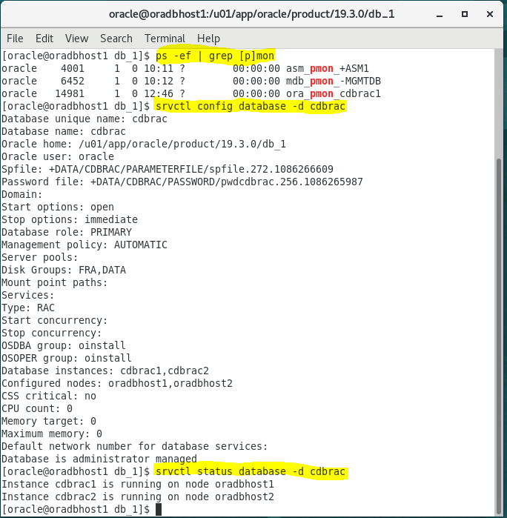

Check the instance/SQLPlus

sqlplus / as sysdba

col instance_name format a30
col instance_name format a30
col instance_name format a30
set lines 100

select instance_name, host_name from v$instance;
select inst_number, inst_name from v$active_instance

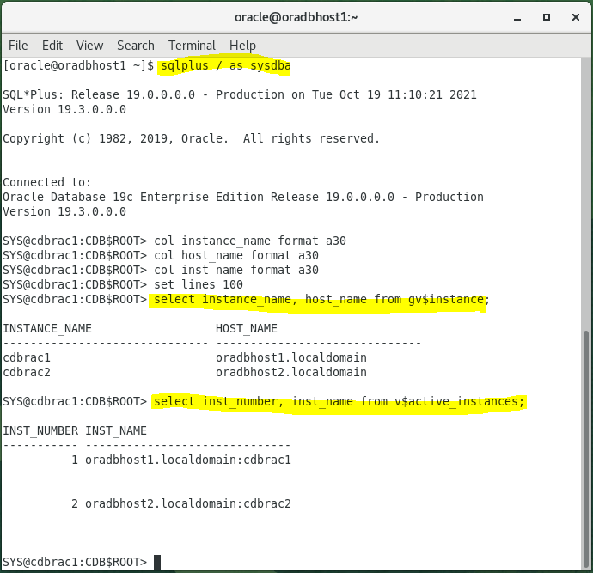

Check the RAC status
With the grid infrastructure environment set:

crsctl stat res –t
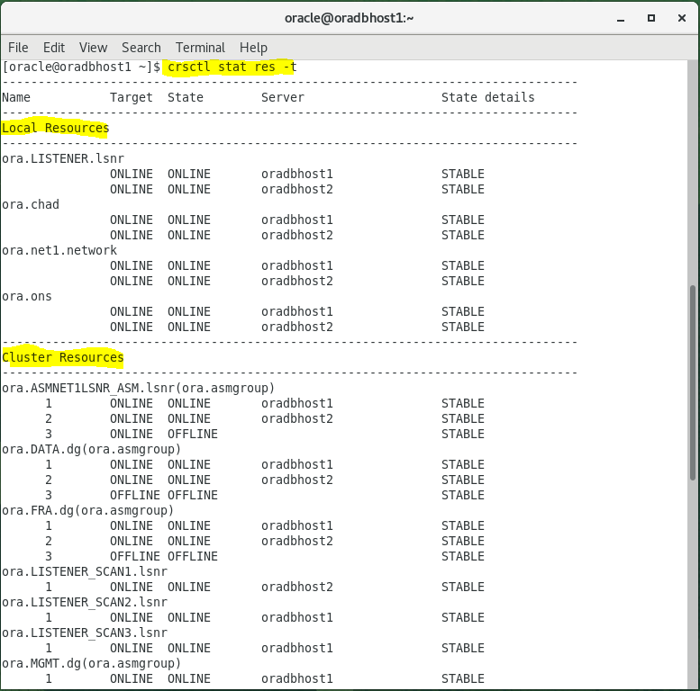

Check Instance and Listener on the second RAC node

ps –ef | grep [p]mon
ps –ef | grep [l]sn

